ASP.NET Core 8.0 Web API

3. Web API Hands on

1. Objectives
- Demonstrate creation of an action method that returns a list of custom class entity objects.
- Create an Employee model class and use the AllowAnonymous attribute and HttpGet action method.
- Understand the use of the FromBody attribute to read a model object from the request body.
- Demonstrate a custom action filter using ActionFilterAttribute and OnActionExecuting to intercept requests.
- Create a custom exception filter to handle application exceptions, log exception details to a file, and return an Internal Server Error response.

2. Software / Tools Used
- Visual Studio
- ASP.NET Core Web API
- C#
- Swagger UI
- Microsoft.AspNetCore.Mvc.WebApiCompatShim NuGet package

3. Procedure and Implementation

3.1 Web API Using Custom Model Class
A custom Employee model class was created with Id, Name, Salary, Permanent, Department, Skills and DateOfBirth properties. Supporting Department and Skill classes were also created.
A private GetStandardEmployeeList method was used to return a list of Employee objects. The EmployeeController GET action returned the employee list and was documented with a 200 OK response type. The result was verified using Swagger.

3.2 Custom Authorization Filter
A Filters folder was created and a CustomAuthFilter class was implemented by inheriting from ActionFilterAttribute. The OnActionExecuting method checks whether the Authorization header is present. If it is missing, the response is 'Invalid request - No Auth token'. If the header does not contain 'Bearer', the response is 'Invalid request - Token present but Bearer unavailable'. The filter was applied to the Employee controller.

3.3 Custom Exception Filter
A CustomExceptionFilter class was created by implementing IExceptionFilter through the OnException method. Exception details were retrieved from the exception context and written to ErrorLog.txt. The Result property was set to return a 500 Internal Server Error response. An exception was intentionally thrown from the Employee GET action and the exception handling was tested using Swagger.

4. Verification Results
Test | Expected Result | Observed Result
Employee GET in Swagger | Employee list with 200 OK | Successfully returned Employee list
Authorization header missing | 400 - Invalid request - No Auth token | Successfully intercepted by CustomAuthFilter
Exception in GET action | 500 Internal Server Error | Successfully returned 500 response
Exception logging | Exception details written to ErrorLog.txt | Log file created successfully

5. Screenshots
Figure 1: Swagger GET response showing the custom Employee list and 200 OK response.
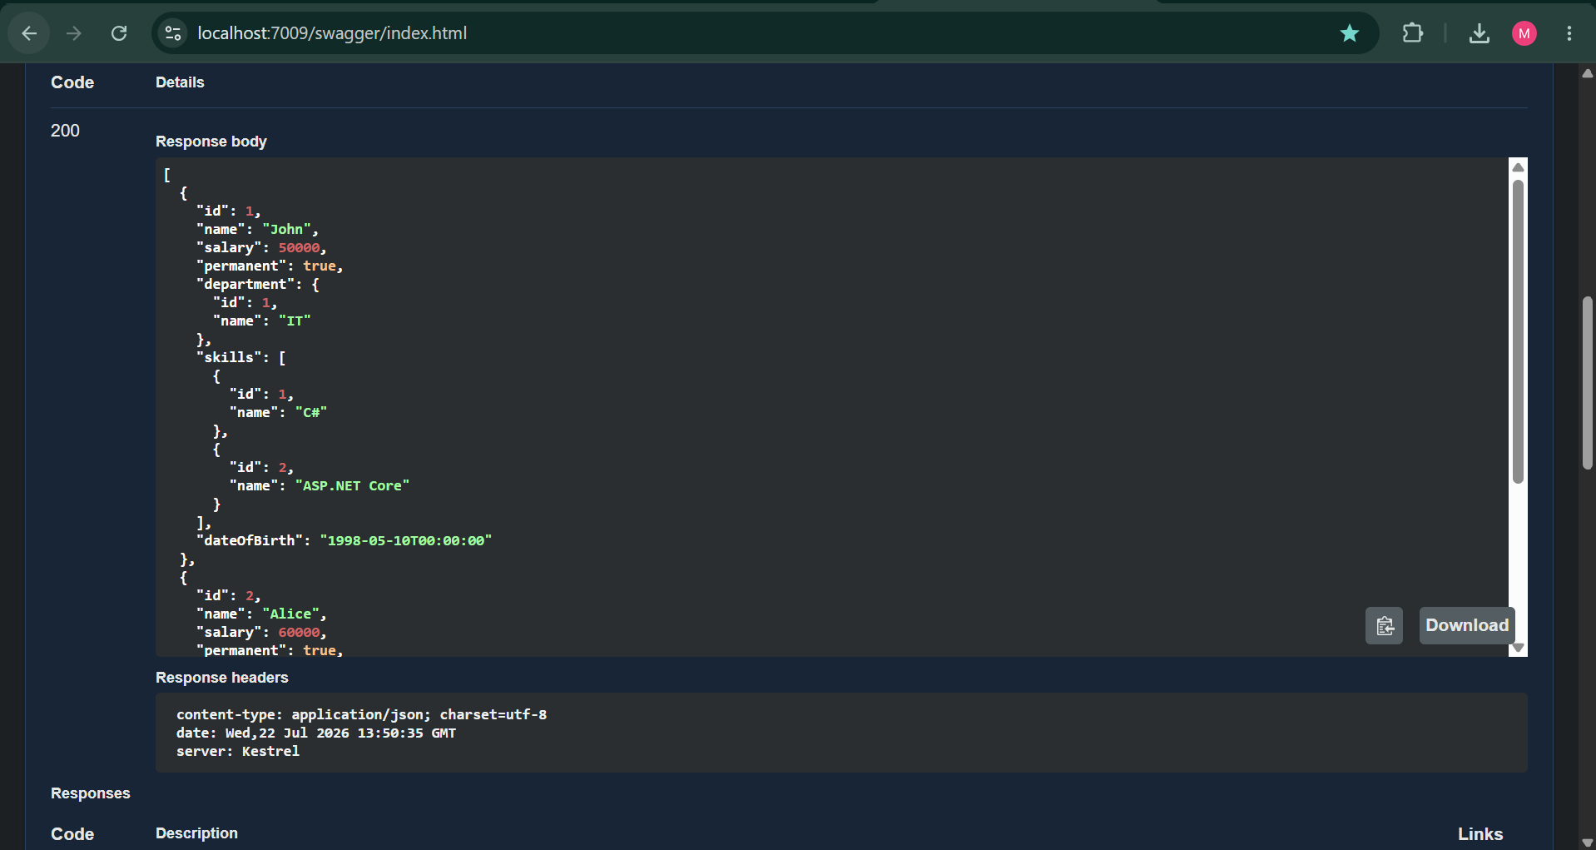

Figure 2: Custom Authorization Filter response showing 'Invalid request - No Auth token'.
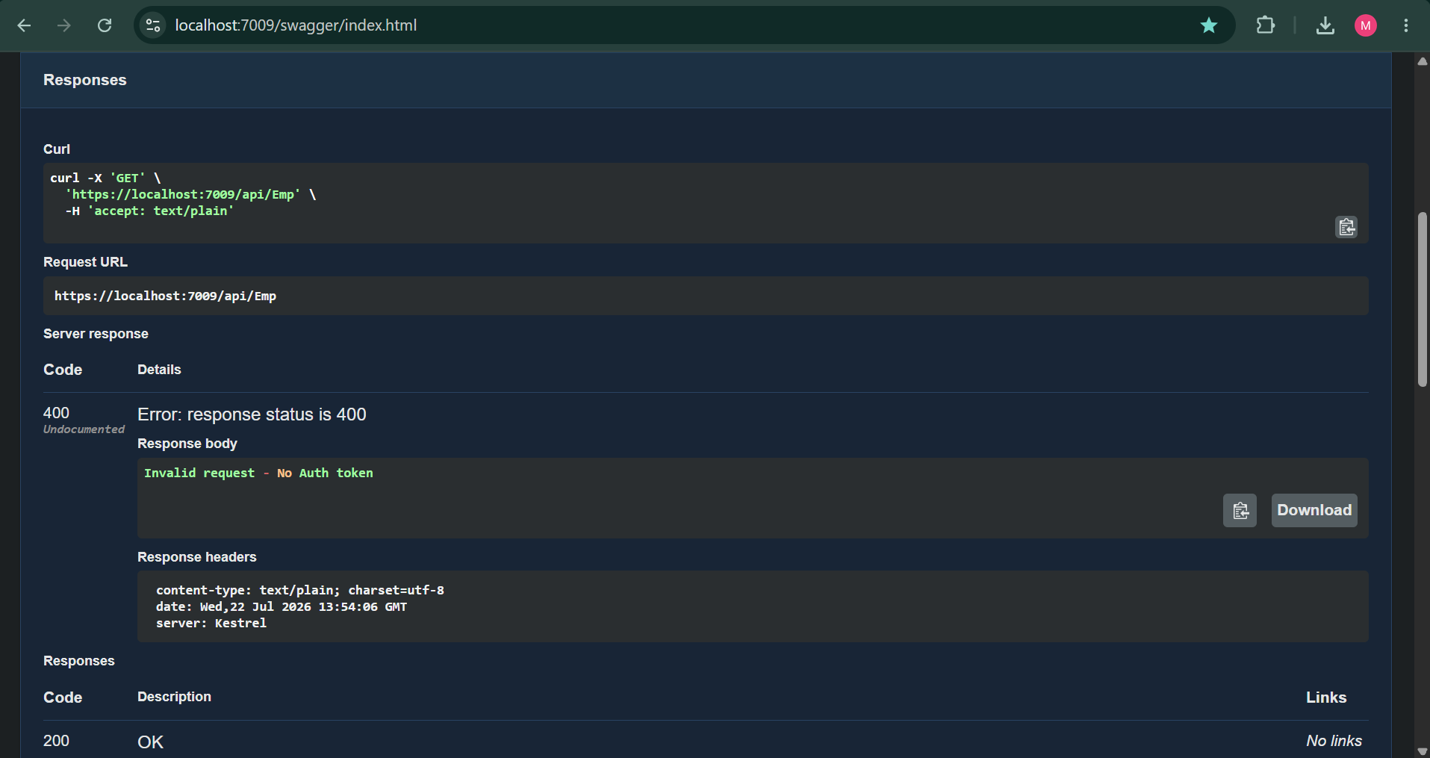

Figure 3: Swagger GET response showing 500 Internal Server Error and 'An internal server error occurred.'.
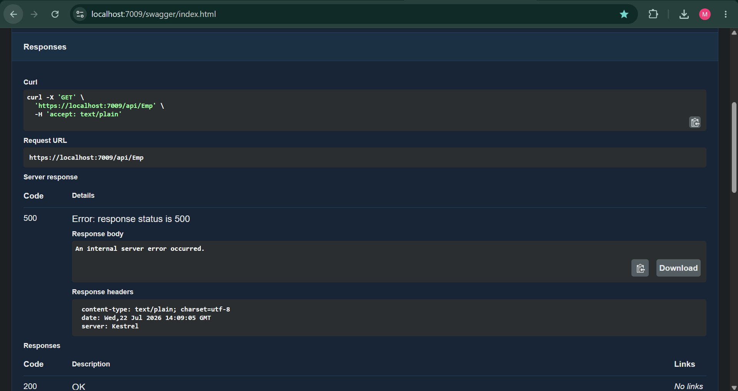

Figure 4: ErrorLog.txt containing the logged exception details.
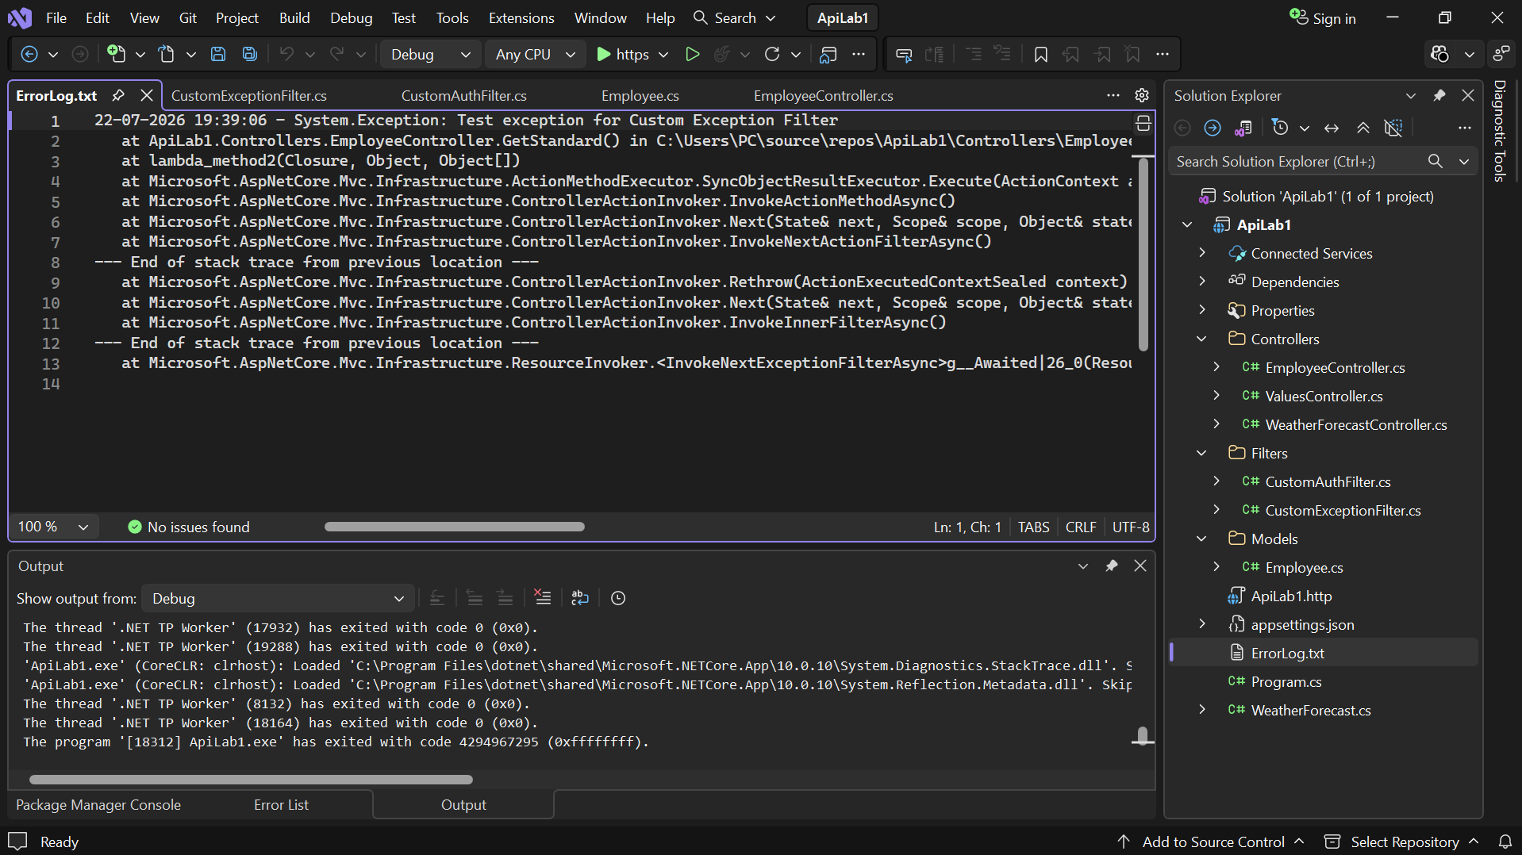

6. Result
Successfully created a custom Employee model and an API action method that returns a list of Employee objects. A custom authorization filter was implemented to validate the Authorization header and Bearer token. A custom exception filter was implemented using IExceptionFilter to intercept exceptions, log exception details to ErrorLog.txt, and return a 500 Internal Server Error response. The functionality was successfully tested using Swagger.

